Chapter 3

**Methodology**

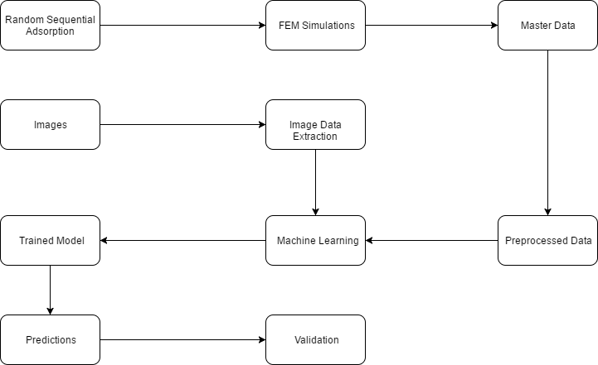

**Figure 3.1**: Flow chart of General Workflow of the project

* 1. **Assumptions**

Before beginning the analysis, the assumptions in the underlying architecture of the project must be understood:

* The analysis is confined to 2-D space. This implies that fibres are considered (and not particles) of infinite length (or equal to length of material in that dimension).
* In the cross-section, all fibres are perfectly circular in shape. That is, the analysis is performed for cylindrical fibres.
* The analysis is confined to two phases of the composite.
* Very small particles will be ignored assuming they have negligible overall effect.
  1. **General Workflow**

The general flow of work of the project is as shown above. First, data is generated using a ‘Random Sequential Adsorption’ model, which generates statistically equivalent (SE) structures with different fibre arrangements. With this, 5 SE structures are generated which are isotropic. Next, full field simulations are performed on these 5 structures and their aggregate properties (Young’s Modulus, Poisson’s Ratio, Shear Modulus) are recorded. After that, these 5 values of each of the properties are averaged to arrive at a single value. This ensures robustness in the model, since there are small variations in properties when the ratio L/D > 20 (L = length of unit cell; D = Diameter of fibre)[ [A Combined Experimental–Numerical Approach for Generating Statistically Equivalent Fibre Distributions for High Strength Laminated Composite Materials](../Research%20Papers/Random%20Particle%20Generation/A%20Combined%20Experimental–Numerical%20Approach%20for%20Generating%20Statistically%20Equivalent%20Fibre%20Distributions%20for%20High%20Strength%20Laminated%20Composite%20Materials.pdf)]. The final properties are then fed to the training data of the ML model, where it is first prepared according to the desired format as is shown later.

Another way of gathering data for the ML model is through real images of fibres scattered in the matrix. The image is recognized and the desired properties (diameter, volume fraction) are directly extracted from the image. This data, coupled with the material properties, is sent for training of the ML model.

Once the data, whether it originated from images or textual data, is prepared and is model-ready, the Machine Learning model is trained using several different algorithms. Finally, predictions are made on unseen data, i.e., composite materials which were not used for training, and the results are validated against FEM and experimental data.

* 1. **Data Generation**

The entire analysis of this project relies on generation of accurate, and uniformly distributed data emulating realistic one. This data would comprise material properties of the matrix and fibres, along with diameter and volume fraction of fibres. For the purpose of the analysis, three volume fractions were considered: 30%, 40%, and 50%.

* + 1. **Data for Stress-Strain Curve**

The first data set is created for building the stress-strain curves for various composites. For this, the following features are considered:

* Young’s Moduli of matrix and fibre
* Poisson’s Ratios of matrix and fibre
* Strain (normally distributed; 10 values considered)
* Volume fraction (5%-30%, in increments of 5%)

The data generated looks as follows:

|  |  |  |  |  |  |  |  |
| --- | --- | --- | --- | --- | --- | --- | --- |
|  | **Stress (Pa)** | **Matrix Young's Modulus (Pa)** | **Matrix Poisson's Ratio** | **Fibre Young's Modulus (Pa)** | **Fibre Poisson's Ratio** | **Strain** | **Volume Fraction (%)** |
| **count** | 6.00e+04 | 6.00e+04 | 6.00e+04 | 6.00e+04 | 6.00e+04 | 6.00e+04 | 6.00e+04 |
| **mean** | 9.159537e+08 | 5.9948e+09 | 0.42476 | 5.063630e+11 | 0.320730 | 0.052192 | 17.500000 |
| **std** | 6.753535e+08 | 2.4735e+09 | 0.01544 | 2.830782e+11 | 0.018896 | 0.030326 | 8.539197 |
| **min** | 2.672000e+06 | 1.1500e+09 | 0.40000 | 1.030000e+10 | 0.282000 | 0.001001 | 5.000000 |
| **25%** | 3.772325e+08 | 4.1600e+09 | 0.41000 | 2.590000e+11 | 0.306750 | 0.026082 | 10.000000 |
| **50%** | 7.670250e+08 | 5.8600e+09 | 0.42400 | 4.845000e+11 | 0.322500 | 0.051775 | 17.500000 |
| **75%** | 1.322200e+09 | 8.0975e+09 | 0.43825 | 7.527500e+11 | 0.338000 | 0.078081 | 25.000000 |
| **max** | 3.958600e+09 | 9.9600e+09 | 0.45000 | 9.990000e+11 | 0.350000 | 0.105000 | 30.000000 |

**Table 3.1**: Summary of Stress-Strain Data Set Generated

As is visible,

* Total size (rows) of data = 60,000
* Number of unique materials = 100 (1 = matrix; 2 = fibre)

This data set is used for constructing the stress-strain curves of various composite materials and to check how closely they resemble the actual (FE simulated) curves.

* + 1. **Generation of Representative Volume Element**

Once the accuracy of the model was verified, the next step was to generate data for higher volume fractions, considering only the final stress and strain values. To generate statistically equivalent Representative Volume Elements (RVE), the hard-core model, also called the **Random Sequential Adsorption** (RSA) model was used. This method creates a set of randomly distributed points inside a square region, with the constraint that no pair of points may be closer points inside a square region, and that no pair of points may be closer than a certain minimum distance.

In this model, structures are created by first setting the values of volume fraction, and limiting the distance between fibres (circles) and between circles and the walls of the unit cell. Thereafter, the required diameter of circles and their number is determined based on the information provided. Finally, the required arrangement is obtained in a random manner to ensure isotropic nature. The code is attached in the ‘Code Snippets’ section.

Using the RSA model, for each matrix-fibre pair with specified volume fraction, 5 different structures were obtained in the form of images, with locations of centres of all circles in a 2D array. This data was further used as input for finite element simulations.

One drawback of the RSA model is that it does not permit the fibre volume fraction to be greater than ~54.7% due to the presence of fibre volume fraction to be greater than ~54.7% due to the presence of the so-called “jamming limit”. As most of the experimental data available was pertaining to composite materials with a greater volume fraction, countering this issue was imperative. To do so, first, the volume fraction was brought up to 54.7%, and then by using *jittering* functionalities, the fibre arrangements were varied randomly and additional fibres were introduced manually into the matrix till the volume fraction reached 60%. This was used only for validation.

* + 1. **Finite Element Method Simulations**

Once 5 different statistically equivalent structures were obtained for each composite material for a particular volume fraction, all 5 structures were simulated using Finite Element Modelling on ANSYS. The features used were:

* Transverse Young’s Moduli
* Transverse Poisson’s Ratios
* Volume Fraction of fibres

For the analysis, *plain strain* conditions were used. Thus, principal strains were introduced along two perpendicular axes, and a third shear strain was introduced in the plane containing these two axes. This can be represented as follows:

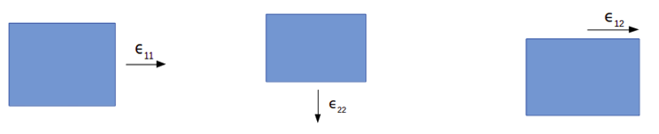

**Figure 3.3**: Plain strain conditions for a 2-D body

Lastly, from the simulations, the average stress values were recorded. From these values, using the tangent formulae (shown below), tangent moduli for the composites were calculated. These moduli were later used as a feature for the ML model.

Tangent Moduli formulae:



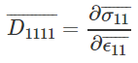

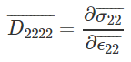

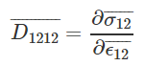

The data obtained was follows:

|  |  |  |  |  |  |
| --- | --- | --- | --- | --- | --- |
|  | **Matrix Young's Modulus (Pa)** | **Matrix Poisson's Ratio** | **Fibre Young's Modulus (Pa)** | **Fibre Poisson's Ratio** | **Volume Fraction** |
| **count** | 3.000000e+02 | 300.000000 | 3.000000e+02 | 300.000000 | 300.000000 |
| **mean** | 5.574183e+09 | 0.305267 | 4.987511e+11 | 0.222166 | 0.400000 |
| **std** | 2.836223e+09 | 0.059083 | 2.654900e+11 | 0.073148 | 0.081786 |
| **min** | 1.078529e+09 | 0.201779 | 4.610544e+10 | 0.102230 | 0.300000 |
| **25%** | 2.931881e+09 | 0.251675 | 2.931493e+11 | 0.158937 | 0.300000 |
| **50%** | 5.475158e+09 | 0.312091 | 4.872371e+11 | 0.216204 | 0.400000 |
| **75%** | 8.189232e+09 | 0.355053 | 6.915839e+11 | 0.285937 | 0.500000 |
| **max** | 9.960097e+09 | 0.398134 | 9.739165e+11 | 0.349943 | 0.500000 |

**Table 3.2**: Description of Data Generated